**MAT2001 – Numerical Methods for Engineers**

**MATLAB Report**

**Prepared by**

**Name: Amit Kumar Sahu**

**Reg No: 18MIS7250**

**Submitted to**

**Dr Satyanarayana Badeti**

**Course Instructor**

**MATLAB Experiment No – 1**

**Name:** Amit Kumar Sahu **Reg No:** 18MIS7250

**Aim:** To implementNewton’s Raphson method for a system for linear system of equation.

**Objective:** we have to solve a nonlinear equation, *f*(*x*)=0 that we cannot easily solve analytically.

**Algorithm :**

This is a very popular method that usually converges rapidly. It solves the equation *f*(*x*)=0, assuming that we can compute *f*′(*x*). The iterations start with an initial guess *x*0 and proceeds as

*xk*+1=*xk*−{*f*(*xk*)/*f*′(*xk*)}.

**MATLAB Code:**

function [x,y]=Newton(fun,funpr,x1,tol,kmax)

x(1)=x1;

y(1)=feval(fun,x(1));

ypr(1)=feval(funpr,x(1));

for k=2:kmax

x(k)=x(k-1)-y(k-1)/ypr(k-1);

y(k)=feval(fun,x(k));

if abs(x(k)-x(k-1))<tol

disp('Newton method has converged');

break;

end

ypr(k)=feval(funpr,x(k));

iter=k;

end

if(iter>=kmax)

disp('zero not found to desired tolerance');

end

n=length(x);

k=1:n;

out=[k' x' y'];

disp(' step x y')

disp(out)

Untitled3.m

f=inline('12*x^3+5*x-40')

df=inline('36*x.^2+5')

[x, y]=Newton(f,df,1,0.00001,10);

% for plotting the root and the functionplot(x(end),y(end),'r*')

hold on

x=0:0.01:2;

f=12*x.^3+5*x-40;

plot(x,f,'k--')

grid on

xlabel('x-axis')

ylabel('y-axis')

title('Newton-Raphson method')

legend('Root','12*x^3+5*x-40')

**Output:**

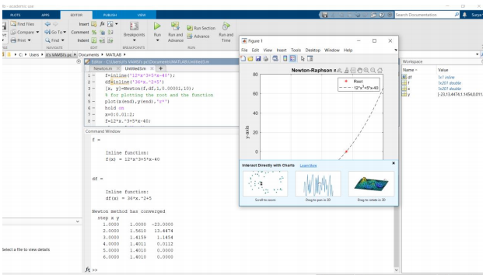

**Graph:**

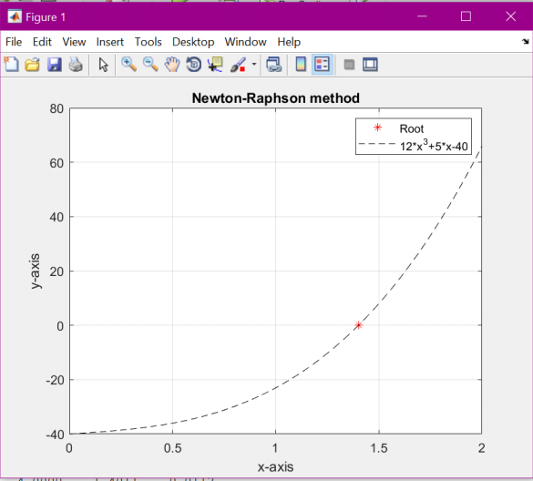

**MATLAB Experiment No – 2**

**Name:** Amit Kumar Sahu **Reg No:** 18MIS7250

**Aim:** To implementNewton’s method for a system of three equations

**Objective:** we have to solve a nonlinear equation, *f*(*x*)=0 that we cannot easily solve analytically.

**Algorithm :**

This is a very popular method that usually converges rapidly. It solves the equation *f*(*x*)=0, assuming that we can compute *f*′(*x*). The iterations start with an initial guess *x*0 and proceeds as

*xk*+1=*xk*−{*f*(*xk*)/*f*′(*xk*)}.

**MATLAB Code:**

function x = NewtonSys(F,J,x0,tol,kmax)

xold=x0; iter=1;

while(iter<=kmax)

y=-feval(J,xold)\feval(F,xold);

xnew=xold+y';

dif=norm(xnew-xold);

disp([iter xnew dif]);

if dif<=tol

x=xnew;

disp('Newton method has converged')

return;

else

xold=xnew;

end

iter=iter+1

end

disp('Newton method has converged')

x=xnew

disp("For A=1 & B=1 the values are")

F=inline('[1+x(1)^2*x(2)-2*x(1); x(1)-x(1)^2*x(2)]');

F1=inline('[1+x(1)^2*x(2)-4*x(1); 3*x(1)-x(1)^2*x(2)]');

F2=inline('[1+x(1)^2*x(2)-3*x(1); 2*x(1)-x(1)^2*x(2)]');

J=inline('[2*x(1)*x(2) - 2, x(1)^2;1 - 2*x(1)*x(2), -x(1)^2]')

x0=[1 1]; tol=0.0001;kmax=20;

disp("For A=1 & B=1 the values are")

x=NewtonSys(F,J,x0,tol,kmax)

disp("For A=1 & B=3 the values are")

x1=NewtonSys(F1,J,x0,tol,kmax)

disp("For A=1 & B=2 the values are")

x2=NewtonSys(F2,J,x0,tol,kmax)

**Output:**

>> runningnewtonsysmethod

For A=1 & B=1 the values are

J =

Inline function:

J(x) = [2*x(1)*x(2) - 2, x(1)^2;1 - 2*x(1)*x(2), -x(1)^2]

For A=1 & B=1 the values are

1 1 1 0

Newton method has converged

x =

1 1

For A=1 & B=3 the values are

1 1 3 2

iter =

2

2 1 3 0

Newton method has converged

x1 =

1 3

For A=1 & B=2 the values are

1 1 2 1

iter =

2

2 1 2 0

Newton method has converged

x2 =

1 2

**MATLAB Experiment No – 3**

**Name:** Amit Kumar Sahu **Reg No:** 18MIS7250

**Aim:** To solve the system secant method

**Objective:** To find root r that uses a succession of [roots](https://en.wikipedia.org/wiki/Root_of_a_function) of [secant lines](https://en.wikipedia.org/wiki/Secant_line) to better approximate a root of a [function](https://en.wikipedia.org/wiki/Function_(mathematics)) *f*.

**Algorithm :** The secant method is defined by the recurrence relationx n = x n – 1 – f ( x n – 1 ) x n – 1 – x n – 2 f ( x n – 1 ) – f ( x n – 2 ) = x n – 2 f ( x n – 1 ) – x n – 1 f ( x n – 2 ) f ( x n − 1 ) − f ( x n − 2 ) . {\displaystyle x_{n}=x_{n-1}-f(x_{n-1}){\frac {x_{n-1}-x_{n-2}}{f(x_{n-1})-f(x_{n-2})}}={\frac {x_{n-2}f(x_{n-1})-x_{n-1}f(x_{n-2})}{f(x_{n-1})-f(x_{n-2})}}.}



As can be seen from the recurrence relation, the secant method requires two initial values, *x*0 and *x*1, which should ideally be chosen to lie close to the root.

**MATLAB Code:**

function [xx, yy]=Secant(f,a,b,tol,kmax)

y(1)=f(a);

y(2)=f(b);

x(1)=a;

x(2)=b;

Dx(1)=0;

Dx(2)=0;

disp(' step x(k-1) x(k) x(k+1) y(k+1) Dx(k+1)')

for k=2:kmax

x(k+1)=x(k)-y(k)*(x(k)-x(k-1))/(y(k)-y(k-1));

y(k+1)=f(x(k+1));

Dx(k+1)=x(k+1)-x(k);

iter=k-1;

out=[iter, x(k-1),x(k),x(k+1),y(k+1),Dx(k+1)];

disp(out)

xx=x(k+1);

yy=y(k+1);

if abs(y(k+1))<tol

disp('Secant method has converged'); break;

end

if (iter>=kmax)

disp('zero not found to desired tolerance');

end

end

f=@(x) 2*x.^2+3*log(x)-1;

a=1;b=2;

tol=0.00001;kmax=10;

[xx, yy]=Secant(f,a,b,tol,kmax);

x=0:0.01:3;

y=2*x.^2+3*log(x)-1;

plot(x,y)

hold on

plot(xx(end),yy(end),'r*')

hold on

xlabel('X-Axis')

ylabel('Y-Axis')

title('Secant Method')

**Output:**

step x(k-1) x(k) x(k+1) y(k+1) Dx(k+1

1.0000 0.5000 1.0000 0.8603 0.0289 -0.1397

2.0000 1.0000 0.8603 0.8562 0.0001 -0.0042

3.0000 0.8603 0.8562 0.8561 -0.0000 -0.0000

secant method has converged

0.8561 -0.0000

**Graph:**

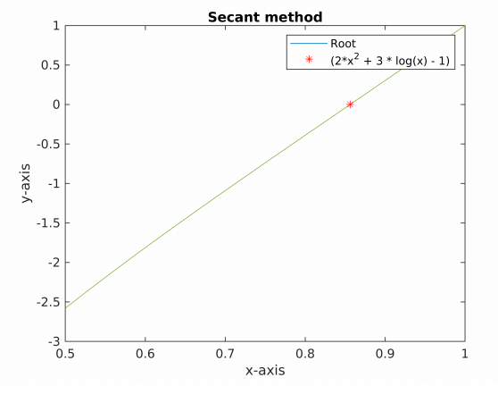

**MATLAB Experiment No – 4**

**Name:** Amit Kumar Sahu **Reg No:** 18MIS7250

**Aim:** To solve the system using Gauss Elimination

**Objective:** Solving [systems of linear equations](https://en.wikipedia.org/wiki/Systems_of_linear_equations). It consists of a sequence of operations performed on the corresponding [matrix](https://en.wikipedia.org/wiki/Matrix_(mathematics)) of coefficients

**Algorithm:** Gaussian elimination allows the computation of the determinant of a square matrix, we have to recall how the elementary row operations change the determinant:

* Swapping two rows multiplies the determinant by −1
* Multiplying a row by a nonzero scalar multiplies the determinant by the same scalar
* Adding to one row a scalar multiple of another does not change the determinant.

If Gaussian elimination applied to a square matrix *A* produces a row echelon matrix *B*, let *d* be the product of the scalars by which the determinant has been multiplied, using the above rules. Then the determinant of *A* is the quotient by *d* of the product of the elements of the diagonal of *B*:



**MATLAB Code:**

function x=Gaussele(A,b);

A=[1 3 5;2 -1 -3;4 5 -1];

b=[14;3;7];

[m,n]=size(A);

if m~=n

error('Matrix A must be square');

end

nb=n+1;

Aug=[A b];

for k=1:n-1

for i=k+1:n

factor=Aug(i,k)/Aug(k,k);

Aug(i,k:nb)=Aug(i,k:nb)-factor*Aug(k,k:nb);

end

end

x=zeros(n,1);

x(n)=Aug(n,nb)/Aug(n,n);

for i=n-1:-1:1

x(i)=(Aug(i,nb)-Aug(i,i+1:n)*x(i+1:n))/Aug(i,i);

end

disp('Gauss elimination method')

x(i);

**Output:**

gaussian_method

Gauss elimination method  
  
ans =  
  
 5  
 -2  
 3

**MATLAB Experiment No – 5**

**Name:** Amit Kumar Sahu **Reg No:** 18MIS7250

**Aim:** To solve the system Gauss Siedel method

**Objective:**  Iteratively solving the [system of linear equations](https://en.wikipedia.org/wiki/System_of_linear_equations)

**Algorithm:**

Inputs: *A*, *b*

Output:

ϕ

{\displaystyle \phi }

Choose an initial guess

ϕ

{\displaystyle \phi }

to the solution

**repeat** until convergence

**for** *i* **from** 1 **until** *n* **do**

σ

←

0

{\displaystyle \sigma \leftarrow 0}

**for** *j* **from** 1 **until** *n* **do**

**if** *j* ≠ *i* **then**

σ

←

σ

+

a

i

j

ϕ

j

{\displaystyle \sigma \leftarrow \sigma +a_{ij}\phi _{j}}

**end if**

**end** (*j*-loop)

ϕ

i

←

1

a

i

i

(

b

i

−

σ

)

{\displaystyle \phi _{i}\leftarrow {\frac {1}{a_{ii}}}(b_{i}-\sigma )}

**end** (*i*-loop)

check if convergence is reached

**end** (repeat)

**MATLAB Code:**

clear ; clc ; close all

n = input('size of the equation system n = ') ;

C = input('Matrix C ' ) ;

b = input('Matrix b ' ) ;

dett = det(C)

if dett == 0

print('cannot solve because det(C) = 0 ')

else

b = b'

A = [ C b ]

for j = 1:(n-1)

for i= (j+1) : n

mult = A(i,j)/A(j,j) ;

for k= j:n+1

A(i,k) = A(i,k) - mult*A(j,k) ;

A

end

end

end

for p = n:-1:1

for r = p+1:n

x(p) = A(p,r)/A(p,r-1)

end

end

end

**Output:**

size of the equation system n =

3

Matrix C

[6 -2 1;1 2 -5;-2 7 2]

Matrix b

[0 0 0]

dett =  
  
 229.0000  
  
  
b =  
  
 0  
 0  
 0  
  
  
A =  
  
 6 -2 1 0  
 1 2 -5 0  
 -2 7 2 0  
  
  
A =  
  
 6 -2 1 0  
 0 2 -5 0  
 -2 7 2 0  
  
  
A =  
 6.0000 -2.0000 1.0000 0  
 0 2.3333 -5.0000 0  
 -2.0000 7.0000 2.0000 0  
  
  
A =  
 6.0000 -2.0000 1.0000 0  
 0 2.3333 -5.1667 0  
 -2.0000 7.0000 2.0000 0  
  
  
A =  
 6.0000 -2.0000 1.0000 0  
 0 2.3333 -5.1667 0  
 -2.0000 7.0000 2.0000 0  
  
  
A =  
 6.0000 -2.0000 1.0000 0  
 0 2.3333 -5.1667 0  
 0 7.0000 2.0000 0  
  
  
A =  
 6.0000 -2.0000 1.0000 0  
 0 2.3333 -5.1667 0  
 0 6.3333 2.0000 0  
  
  
A =  
 6.0000 -2.0000 1.0000 0  
 0 2.3333 -5.1667 0  
 0 6.3333 2.3333 0  
  
  
A =  
  
 6.0000 -2.0000 1.0000 0  
 0 2.3333 -5.1667 0  
 0 6.3333 2.3333 0  
  
  
A =  
  
 6.0000 -2.0000 1.0000 0  
 0 2.3333 -5.1667 0  
 0 0 2.3333 0  
  
  
A =  
  
 6.0000 -2.0000 1.0000 0  
 0 2.3333 -5.1667 0  
 0 0 16.3571 0  
  
  
A =  
  
 6.0000 -2.0000 1.0000 0  
 0 2.3333 -5.1667 0  
 0 0 16.3571 0  
  
  
x =  
  
 0 -2.2143  
  
  
x =  
  
 -0.3333 -2.2143  
  
  
x =  
  
 -0.5000 -2.2143

**MATLAB Experiment No – 6**

**Name:** Amit Kumar Sahu **Reg No:** 18MIS7250

**Aim:** To solve the system Jacobi method

**Objective:** For determining the solutions of a [strictly diagonally dominant](https://en.wikipedia.org/wiki/Diagonally_dominant_matrix) [system of linear equations](https://en.wikipedia.org/wiki/System_of_linear_equations).

**Algorithm :**

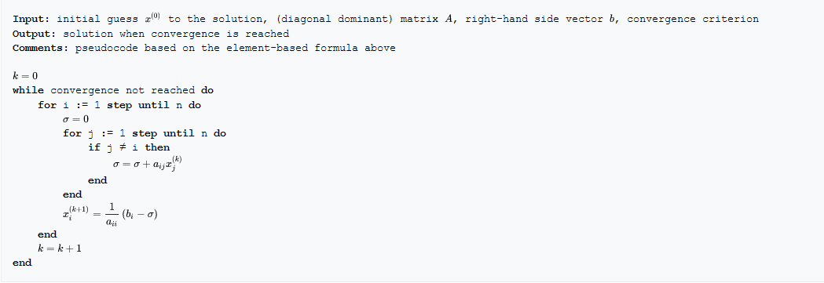

**MATLAB Code:**

clc;

clear all;

A=[5 -2 3;-3 9 1;2 -1 -7]

b=[-1;2;3]

N=40

x=[1,1,1]

jacobi(A, b, N)

function jacobi(A, b, N)

test=all((2*abs(diag(A)))- sum(abs(A),2)>=0);

if test==0

A([1 2],:) = A([2 1],:);

b([1 2]) = b([2 1]);

end

test=all((2*abs(diag(A)))- sum(abs(A),2)>=0);

if test==0

A([2 1],:) = A([1 2],:);

b([2 1]) = b([1 2]);

A([1 3],:) = A([3 1],:);

b([1 3]) = b([3 1]);

disp("not a dominant vector")

end

disp(" dominant vector")

d=diag(A);

D=diag(d);

disp("Displaying the diagonal matrix")

disp(D)

D_inv=inv(D);

disp("Displaying the inverse of diagonal matrix")

disp(D_inv)

E=A-D;

disp("Displaying remainder matrix")

disp(E)

x=[1;1;1];

T=-D_inv*E;

C=D_inv*b;

for j=1:N

x=T*x+C;

end

disp("Here are the result of the following matrix: ")

disp(x)

end

**Output:**

A =  
  
 5 -2 3  
 -3 9 1  
 2 -1 -7  
  
  
b =  
  
 -1  
 2  
 3  
  
  
N =  
  
 40  
  
  
x =  
  
 1 1 1  
  
 dominant vector  
Displaying the diagonal matrix  
 5 0 0  
 0 9 0  
 0 0 -7  
  
Displaying the inverse of diagonal matrix  
 0.2000 0 0  
 0 0.1111 0  
 0 0 -0.1429  
  
Displaying remainder matrix  
 0 -2 3  
 -3 0 1  
 2 -1 0  
  
Here are the result of the following matrix:   
 0.1861  
 0.3312  
 -0.4227

**MATLAB Experiment No – 7**

**Name:** Amit Kumar Sahu **Reg No:** 18MIS7250

**Aim:** To solve the system using LU Decomposition

**Objective:** Factors a [matrix](https://en.wikipedia.org/wiki/Matrix_(mathematics)) as the product of a lower [triangular matrix](https://en.wikipedia.org/wiki/Triangular_matrix) and an upper triangular matrix.

**Algorithm:**

Let *A* be a square matrix. An **LU factorization** refers to the factorization of *A*, with proper row and/or column orderings or permutations, into two factors – a lower triangular matrix *L* and an upper triangular matrix *U*:

A=LU

In the lower triangular matrix all elements above the diagonal are zero, in the upper triangular matrix, all the elements below the diagonal are zero. For example, for a 3 × 3 matrix *A*, its LU decomposition looks like this:

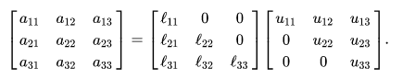[ a 11 a 12 a 13 a 21 a 22 a 23 a 31 a 32 a 33 ] = [ ℓ 11 0 0 ℓ 21 ℓ 22 0 ℓ 31 ℓ 32 ℓ 33 ] [ u 11 u 12 u 13 0 u 22 u 23 0 0 u 33 ] . {\displaystyle {\begin{bmatrix}a_{11}&a_{12}&a_{13}\\a_{21}&a_{22}&a_{23}\\a_{31}&a_{32}&a_{33}\end{bmatrix}}={\begin{bmatrix}\ell _{11}&0&0\\\ell _{21}&\ell _{22}&0\\\ell _{31}&\ell _{32}&\ell _{33}\end{bmatrix}}{\begin{bmatrix}u_{11}&u_{12}&u_{13}\\0&u_{22}&u_{23}\\0&0&u_{33}\end{bmatrix}}.}

Without a proper ordering or permutations in the matrix, the factorization may fail to materialize. For example, it is easy to verify (by expanding the matrix multiplication) that a 11 = l 11 u 11 {\textstyle a_{11}=l_{11}u_{11}} . If a 11 = 0 {\textstyle a_{11}=0} , then at least one of l 11 {\textstyle l_{11}} and u 11 {\textstyle u_{11}} has to be zero, which implies that either *L* or *U* is [singular](https://en.wikipedia.org/wiki/Singular_matrix). This is impossible if *A* is nonsingular (invertible). This is a procedural problem. It can be removed by simply reordering the rows of *A* so that the first element of the permuted matrix is nonzero. The same problem in subsequent factorization steps can be removed the same way; see the basic procedure below.

**MATLAB Code:**

clc;

clear all;

A = [10 -7 0

-3 2 6

5 -1 5];

[L,U] = lu(A)

disp("calculating L*U")

L*U

[L,U,P] = lu(A)

disp("calculating P'*L*U")

P'*L*U

**Output:**

L =  
  
 1.0000 0 0  
 -0.3000 -0.0400 1.0000  
 0.5000 1.0000 0  
  
  
U =  
  
 10.0000 -7.0000 0  
 0 2.5000 5.0000  
 0 0 6.2000  
  
calculating L*U  
  
ans =  
  
 10.0000 -7.0000 0  
 -3.0000 2.0000 6.0000  
 5.0000 -1.0000 5.0000  
  
  
L =  
  
 1.0000 0 0  
 0.5000 1.0000 0  
 -0.3000 -0.0400 1.0000  
  
  
U =  
  
 10.0000 -7.0000 0  
 0 2.5000 5.0000  
 0 0 6.2000  
  
  
P =  
  
 1 0 0  
 0 0 1  
 0 1 0  
  
calculating P'*L*U  
  
ans =  
  
 10.0000 -7.0000 0  
 -3.0000 2.0000 6.0000  
 5.0000 -1.0000 5.0000

**MATLAB Experiment No – 8**

**Name:** Amit Kumar Sahu **Reg No:** 18MIS7250

**Aim:** Implementing Power Method.

**Objective:** The algorithm will produce a number λ {\displaystyle \lambda } Lambda, which is the greatest (in absolute value) [eigenvalue](https://en.wikipedia.org/wiki/Eigenvalue) of A {\displaystyle A} A, and a nonzero vector v {\displaystyle v} v, which is a corresponding [eigenvector](https://en.wikipedia.org/wiki/Eigenvector) of λ {\displaystyle \lambda } Lambda, that is, A v = λ v {\displaystyle Av=\lambda v} Av=(Lambda)*(v).

**Algorithm:** The power iteration algorithm starts with a vector b 0 {\displaystyle b_{0}} b0, which may be an approximation to the dominant eigenvector or a random vector. The method is described by the [recurrence relation](https://en.wikipedia.org/wiki/Recurrence_relation)

b k + 1 = A b k ‖ A b k ‖ {\displaystyle b_{k+1}={\frac {Ab_{k}}{\|Ab_{k}\|}}} 

**MATLAB Code:**

n=input('Enter dimension of the matrix, n: ');

A = zeros(n,n);

x = zeros(1,n);

y = zeros(1,n);

tol = input('Enter the tolerance, tol: ');

m = input('Enter maximum number of iterations, m: ');

A=[1 2 0; -2 1 2; 1 3 1];

x=[1 1 1];

k = 1; lp = 1;

amax = abs(x(1));

for i = 2 : n

if abs(x(i)) > amax

amax = abs(x(i));

lp = i;

end

end

for i = 1 : n

x(i) = x(i)/amax;

end

fprintf('\n\n Ite. Eigenvalue ............Eigenvectores............\n');

while k <= m

for i = 1 : n

y(i) = 0;

for j = 1 : n

y(i) = y(i) + A(i,j) * x(j);

end

end

ymu = y(lp);

lp = 1;

amax = abs(y(1));

for i = 2 : n

if abs(y(i)) > amax

amax = abs(y(i));

lp = i;

end

end

if amax <= 0

fprintf('0 eigenvalue - select another ');

fprintf('initial vector and begin again\n');

else

err = 0;

for i = 1 : n

t = y(i)/y(lp);

if abs(x(i)-t) > err

err = abs(x(i)-t);

end

x(i) = t;

end

fprintf('%4d %11.8f', k, ymu);

for i = 1 : n

fprintf(' %11.8f', x(i));

end

fprintf('\n');

if err <= tol

fprintf('\n\nThe eigenvalue after %d iterations is: %11.8f \n',k, ymu);

fprintf('The corresponding eigenvector is: \n');

for i = 1 : n

fprintf(' %11.8f \n', x(i));

end

fprintf('\n');

break;

end

k = k+1;

end

end

if k > m

fprintf('Method did not converge within %d iterations\n', m);

end

**Output:**

powermethod

Enter dimension of the matrix, n:

3

Enter the tolerance, tol:

0.001

Enter maximum number of iterations, m:

8

Ite. Eigenvalue ............Eigenvectores............  
 1 3.00000000 0.60000000 0.20000000 1.00000000  
 2 2.20000000 0.45454545 0.45454545 1.00000000  
 3 2.81818182 0.48387097 0.54838710 1.00000000  
 4 3.12903226 0.50515464 0.50515464 1.00000000  
 5 3.02061856 0.50170648 0.49488055 1.00000000  
 6 2.98634812 0.49942857 0.49942857 1.00000000  
 7 2.99771429 0.49980938 0.50057186 1.00000000  
 8 3.00152497 0.50006351 0.50006351 1.00000000  
  
  
The eigenvalue after 8 iterations is: 3.00152497   
The corresponding eigenvector is:   
 0.50006351   
 0.50006351   
 1.00000000

**MATLAB Experiment No – 9**

**Name:** Amit Kumar Sahu **Reg No:** 18MIS7250

**Aim:** Implementing Lagrange’s interpolation.

**MATLAB Code:**

function y=lagrange(x,pointx,pointy)

n=size(pointx,2);

L=ones(n,size(x,2));

if (size(pointx,2)~=size(pointy,2))

fprintf(1,'\nERROR!\nPOINTX and POINTY must have the same number of elements\n');

y=NaN;

else

for i=1:n

for j=1:n

if (i~=j)

L(i,:)=L(i,:).*(x-pointx(j))/(pointx(i)-pointx(j));

end

end

end

y=0;

for i=1:n

y=y+pointy(i)*L(i,:);

end

end

**Output:**

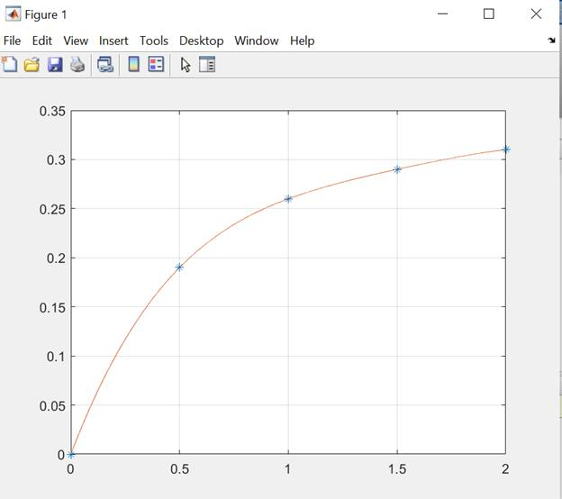

**MATLAB Experiment No – 10**

**Name:** Amit Kumar Sahu **Reg No:** 18MIS7250

**Aim:** To solve the system using Tridiagonal Method (Thomas Algorithm).

**Objective:** used to solve [tridiagonal systems of equations](https://en.wikipedia.org/wiki/Tridiagonal_matrix)

**Algorithm:**

Sub TriDiagonal_Matrix_Algorithm(N%, A#(), B#(), C#(), D#(), X#())

Dim i%, W#

For i = 2 To N

W = A(i) / B(i - 1)

B(i) = B(i) - W * C(i - 1)

D(i) = D(i) - W * D(i - 1)

Next i

X(N) = D(N) / B(N)

For i = N - 1 To 1 Step -1

X(i) = (D(i) - C(i) * X(i + 1)) / B(i)

Next i

End Sub

**MATLAB Code:**

%Solving Linear system by using Thomas algorithm /Tridiagonal system

clc;clear all;close all;

format 'short'

%%Triangularization

m=input('Enter the order of TDmatrix:=');%Choose any square matrix

%m=4

% Lower diagonal element such that first entry is zero.

a=input('\n Enter the lower diagonal vector:=')%lower diagonal elements

%a=[0 -1 -1 -1];

b=input('\n Enter the Main diagonal vector:=')%diagonal elements

%b=[2.04 2.04 2.04 2.04];

% Upper diagonal element such that last entry is zero.

c=input('\n Enter the upper diagonal vector:=')%upperdiagonal elements

% c=[-1 -1 -1 0];

d=input('Enter the right side vector:=')

%d=[4.08 0.8 0.8 2.08];

alpha=zeros(1,m);

for i=1:m

if i==1

alpha(i)=b(i);

beta(i)=d(i);

else

ivalue=i

alpha(i)=b(i)-(a(i)/alpha(i-1))*c(i-1);

beta(i)=d(i)-(a(i)/alpha(i-1))*beta(i-1);

end

end

alpha

beta

%% Back substitution

x=zeros(1,m);

for i=m:-1:1

if i==m

x(i)=beta(i)/alpha(i);

else

x(i)=(beta(i)-c(i)*x(i+1))/alpha(i);

end

end

x

**Output:**

Enter the order of TDmatrix:=

5

Enter the lower diagonal vector:=

[0 1 1 1 1]

a =  
  
 0 1 1 1 1  
  
  
 Enter the Main diagonal vector:=

[-2 -2 -2 -2 -2]

b =  
  
 -2 -2 -2 -2 -2  
  
  
 Enter the upper diagonal vector:=

[1 1 1 1 0]

c =  
  
 1 1 1 1 0  
  
Enter the right side vector:=

[1;0;0;0;0]

d =  
  
 1  
 0  
 0  
 0  
 0  
  
  
ivalue =  
  
 2  
  
  
ivalue =  
  
 3  
  
  
ivalue =  
  
 4  
  
  
ivalue =  
  
 5  
  
  
alpha =  
  
 -2.0000 -1.5000 -1.3333 -1.2500 -1.2000  
  
  
beta =  
  
 1.0000 0.5000 0.3333 0.2500 0.2000  
  
  
x =  
  
 -0.8333 -0.6667 -0.5000 -0.3333 -0.1667

**MATLAB Experiment No – 11**

**Name:** Amit Kumar Sahu **Reg No:** 18MIS7250

**Aim:** To solve the system of equation using Trapezoidal rule.

**Objective:** approximating the [definite integral](https://en.wikipedia.org/wiki/Integral).

**Algorithm:**



**MATLAB Code:**

clc;

clear all;

f=@(x)cosh(x);

% create a handle to the function f with an @ sign.

a=input('Enter lower limit a: ');

b=input('Enter upper limit b: ');

n=input('Enter the no. of subinterval: ');

h=(b-a)/n;

sum=0;

for k=1:1:n-1

x(k)=a+k*h;

y(k)=f(x(k));

sum=sum+y(k);

end

% Formula: (h/2)*[(y0+yn)+2*(y2+y3+..+yn-1)]

answer=(h/2)*(f(a)+f(b)+2*sum);

fprintf('\n The value of integration is %f',answer);

**Output:**

Enter lower limit a:

0

Enter upper limit b:

2

Enter the no. of subinterval:

4

The value of integration is 3.702107

**MATLAB Experiment No – 12**

**Name:** Amit Kumar Sahu **Reg No:** 18MIS7250

**Aim:** To solve the system using Simpson’s 1/3rd Rule

**Objective:** [approximations](https://en.wikipedia.org/wiki/Approximation) for [definite integrals](https://en.wikipedia.org/wiki/Definite_integral)

**Algorithm:**

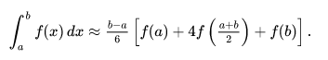

**MATLAB Code:**

clc;

clear all;

f=@(x)cosh(x); %Change here for different function

a=input('Enter lower limit a: ');

b=input('Enter upper limit b: ');

n=input('Enter the number of sub-intervals n: ');

h=(b-a)/n;

if rem(n,2)==1

fprintf('\n Enter valid n!!!');

n=input('\n Enter n as even number ');

end

for k=1:1:n

x(k)=a+k*h;

y(k)=f(x(k));

end

so=0;se=0;

for k=1:1:n-1

if rem(k,2)==1

so=so+y(k);%sum of odd terms

else

se=se+y(k); %sum of even terms

end

end

% Formula: (h/3)*[(y0+yn)+2*(y3+y5+..odd term)+4*(y2+y4+y6+...even terms)]

answer=h/3*(f(a)+f(b)+4*so+2*se);

fprintf('\n The value of integration is %f',answer); % exmple The value of integration is 0.408009

**Output:**

1

Enter upper limit b:

2

Enter the number of sub-intervals n:

16

The value of integration is 2.451659

**MATLAB Experiment No - 13**

**Name:** Amit Kumar Sahu **Reg No:** 18MIS7250

**Aim:** To solve the system of equation using Picard’s Method.

**Objective:** approximating the [integral](https://en.wikipedia.org/wiki/Integral).

**Algorithm:**

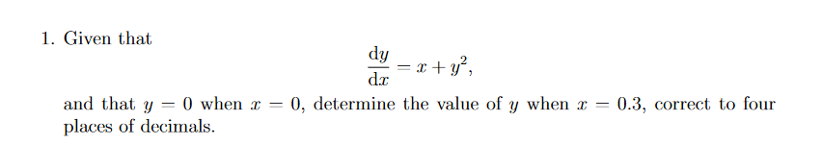

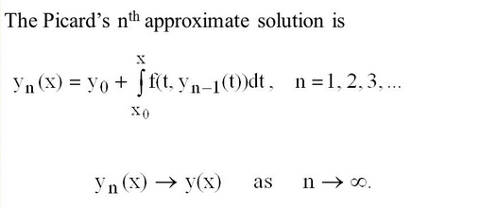

**MATLAB Code:**

clc

clear all

close all

syms x;

y0=2;

x0=1;

f=2-(y0/x);

y1=int(f,x,x0,x)+y0;

f=subs(y1,x);

y2=int(f,x,x0,x)+y0;

f=subs(y2,x);

y3=int(f,x,x0,x)+y0;

f=subs(y3,x);

y4=int(f,x,x0,x)+y0;

y1=vpa(subs(y1,1.2))

y2=vpa(subs(y2,1.2))

y3=vpa(subs(y3,1.2))

y4=vpa(subs(y4,1.2))

**Output:**

y1 =  
   
2.035356886412090747576563949691  
   
   
y2 =  
   
2.4024282636945088970918767396292  
   
   
y3 =  
   
2.4401236248833720049217927104442

y4 =  
   
2.4426716721755710241909393063999

**MATLAB Experiment No - 14**

**Name:** Amit Kumar Sahu **Reg No:** 18MIS7250

**Aim:** To solve the system of equation using Runge Kutta Method.

**Objective:** approximating the ODE.

**Algorithm:**

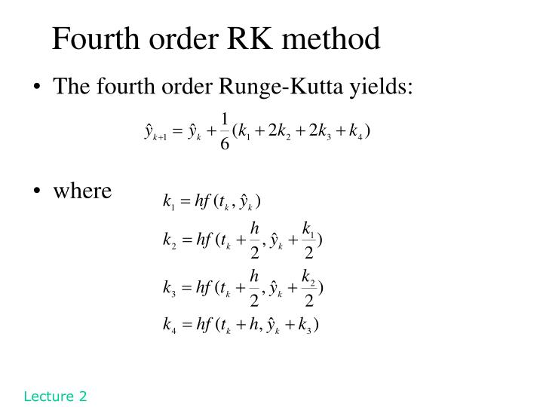

**MATLAB Code:**

clc

clear all

close all

f=input('Enter the function:');

x_initial=input('Enter x initial value:');

y_initial=input('Enter y initial value:');

h=input('Enter h value:');

X=zeros(10,1);

Y=zeros(10,1);

for i=1:10

y=y_initial;

x=x_initial;

X(i)=x_initial;

Y(i)=y_initial;

k1=h*f(x,y);

k2=h*f(x+h/2,y+k1/2);

k3=h*f(x+h/2,y+k2/2);

k4=h*f(x+h,y+k3);

k=(1/6)*(k1+2*k2+2*k3+k4);

y_initial=y+k;

x_initial=x+h;

end

solution=[X Y]

plot(X,Y,':.')

**Output:**

Enter the function:

@(x,y) (x+y)

Enter x initial value:

0

Enter y initial value:

1

Enter h value:

0.2

solution =  
  
 0 1.0000  
 0.2000 1.2428  
 0.4000 1.5836  
 0.6000 2.0442  
 0.8000 2.6510  
 1.0000 3.4365  
 1.2000 4.4401  
 1.4000 5.7103  
 1.6000 7.3059  
 1.8000 9.2990

**Graph:**

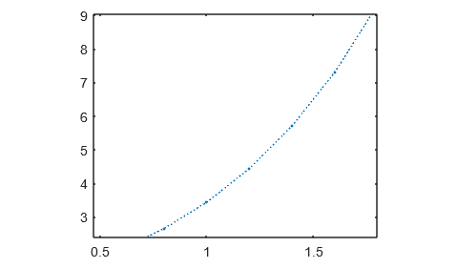

**MATLAB Experiment No - 15**

**Name:** Amit Kumar Sahu **Reg No:** 18MIS7250

**Aim:** To solve the system laplace equation.

**Objective:** approximating the PDE.

**MATLAB Code:**

% Solving the 2-D Laplace's equation by the Finite Difference

...Method

% Numerical scheme used is a second order central difference in space

...(5-point difference)

%%

clc

clear all

%Specifying parameters

nx=60; %Number of steps in space(x)

ny=60; %Number of steps in space(y)

niter=10000; %Number of iterations

dx=2/(nx-1); %Width of space step(x)

dy=2/(ny-1); %Width of space step(y)

x=0:dx:2; %Range of x(0,2) and specifying the grid points

y=0:dy:2; %Range of y(0,2) and specifying the grid points

%%

%Initial Conditions

p=zeros(ny,nx); %Preallocating p

pn=zeros(ny,nx); %Preallocating pn

%%

%Boundary conditions

p(:,1)=0;

p(:,nx)=y;

p(1,:)=p(2,:); %Neumann conditions

p(ny,:)=p(ny-1,:); ...same as above

%%

%Explicit iterative scheme with C.D in space (5-point difference)

j=2:nx-1;

i=2:ny-1;

for it=1:niter

pn=p;

p(i,j)=((dy^2*(pn(i+1,j)+pn(i-1,j)))+(dx^2*(pn(i,j+1)+pn(i,j-1))))/(2*(dx^2+dy^2));

%Boundary conditions (Neumann conditions)

p(:,1)=0;

p(:,nx)=y;

p(1,:)=p(2,:);

p(ny,:)=p(ny-1,:);

end

%%

%Plotting the solution

surf(x,y,p,'EdgeColor','none');

shading interp

title({'2-D Laplace''s equation';['{\itNumber of iterations} = ',num2str(it)]})

xlabel('Spatial co-ordinate (x) \rightarrow')

ylabel('{\leftarrow} Spatial co-ordinate (y)')

zlabel('Solution profile (P) \rightarrow')

**Output:**

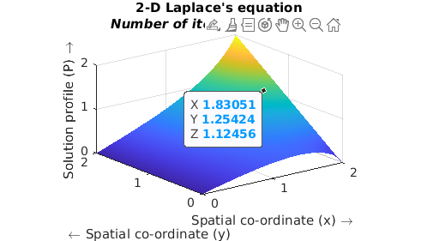

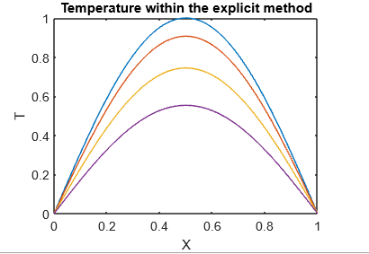

**MATLAB Experiment No - 16**

**Name:** Amit Kumar Sahu **Reg No:** 18MIS7250

**Aim:** To solve the system of heat equation

**Objective:** solve the equation within the explicit method

**MATLAB Code:**

% Explicit Method

clear;

% Parameters to define the heat equation and the range in space and time

L = 1.; % Length of the wire

T =1.; % Final time

% Parameters needed to solve the equation within the explicit method

maxk = 2500; % Number of time steps

dt = T/maxk;

n = 50; % Number of space steps

dx = L/n;

cond = 1/4; % Conductivity

b = 2.*cond*dt/(dx*dx); % Stability parameter (b=<1)

% Initial temperature of the wire: a sinus.

for i = 1:n+1

x(i) =(i-1)*dx;

u(i,1) =sin(pi*x(i));

end

% Temperature at the boundary (T=0)

for k=1:maxk+1

u(1,k) = 0.;

u(n+1,k) = 0.;

time(k) = (k-1)*dt;

end

% Implementation of the explicit method

for k=1:maxk % Time Loop

for i=2:n; % Space Loop

u(i,k+1) =u(i,k) + 0.5*b*(u(i-1,k)+u(i+1,k)-2.*u(i,k));

end

end

% Graphical representation of the temperature at different selected times

figure(1)

plot(x,u(:,1),'-',x,u(:,100),'-',x,u(:,300),'-',x,u(:,600),'-')

title('Temperature within the explicit method')

xlabel('X')

ylabel('T')

figure(2)

mesh(x,time,u')

title('Temperature within the explicit method')

xlabel('X')

ylabel('Temperature')

**Graph:**

**3D Graph**

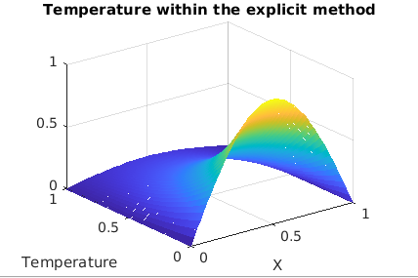

**2-D Graph**

